Course Name: | Artificial Intelligence Laboratory | Semester: | VI
Date of Performance: | 04 / 04 / 26 | DIV/ Batch No: | A1
Student Name: | Aaryan Sharma | Roll No: | 16010123012

Experiment No: 7
Title: Solving planning problems using STRIPS or PDDL tools.

Aim: To write STRIPS scripts to solve planning problem and implement them using PDDL tools

Objectives of the Experiment:
To write STRIPS scripts to solve planning problem and implement them using PDDL tools

COs to be achieved:
CO2: Analyze and solve problems for goal based agent architecture (searching and planning algorithms).

Books/ Journals/ Websites referred:
- https://editor.planning.domains/

Theory:
Planning is an important area in Artificial Intelligence where an intelligent agent determines a sequence of actions required to achieve a specific goal from an initial state. Unlike traditional search techniques, planning uses logical representations of actions and states to efficiently reach the desired goal.
One commonly used representation for planning problems is STRIPS (Stanford Research Institute Problem Solver). STRIPS represents actions using three main components:
- Preconditions – Conditions that must be true before performing an action.
- Add list – Facts that become true after performing the action.
- Delete list – Facts that become false after performing the action.
Planning problems are often modeled using PDDL (Planning Domain Definition Language), which allows the specification of:
- The domain (types of objects, predicates, and actions)
- The problem (initial state and goal state)

Example: Blocks World Problem
Consider a Blocks World environment where the goal is to place Block A on top of Block B.

1. Searching Approach
A search algorithm treats every block configuration as a separate state.
Process
- The algorithm observes the current arrangement of blocks.
- It generates all possible moves such as:
  - Pick up block A
  - Move block B
  - Place block C on the table
Limitation
The search algorithm does not understand the relationships between blocks. It simply explores possible states until it finds the goal state.
If the number of blocks increases, the state space grows exponentially, making the search inefficient.

2. Planning Approach
A planning algorithm analyzes the logical structure of the state.
Example predicates:
- On(A, Table)
- On(B, Table)
- Clear(A)
- Clear(B)
Process
The planner starts from the goal state and reasons backward.
Goal:
On(A, B)
To achieve this goal:
- Block A must be clear
- Block B must be clear
If another block (for example C) is on top of A, the planner deduces that C must be moved first.
Advantages
- Eliminates irrelevant actions
- Reduces search space
- Produces efficient action sequences
Activity
Chosen Planning Problem:
A waiter is in a restaurant. Two food orders are ready in the kitchen. The waiter needs to pick them up and deliver them to the correct tables.
● Locations: Kitchen, Table1, Table2
● Agent: Waiter
● Items: Food1 (for Table1), Food2 (for Table2)
● Actions: Pickup, Deliver, Walk
● Goal: Food1 is at Table1, Food2 is at Table2, Waiter is back at Kitchen

PDDL Script for solving problem: (Domain and problem script)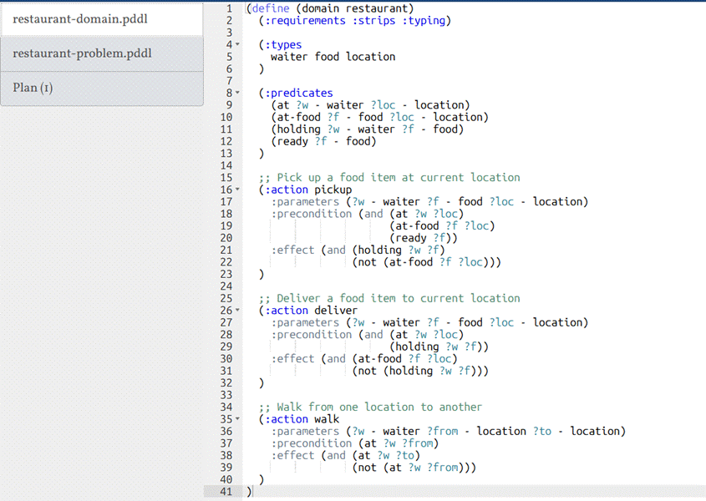

Plan1: Deliver both orders one at a time (Optimal)
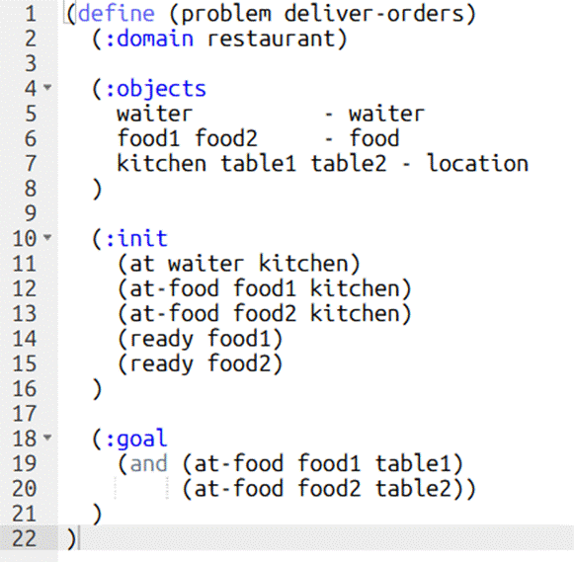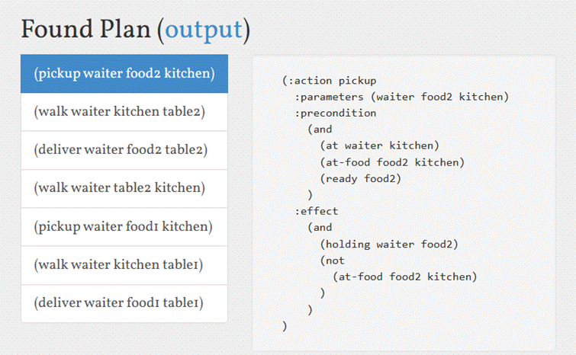

Plan2: Pick up both, deliver food1 first
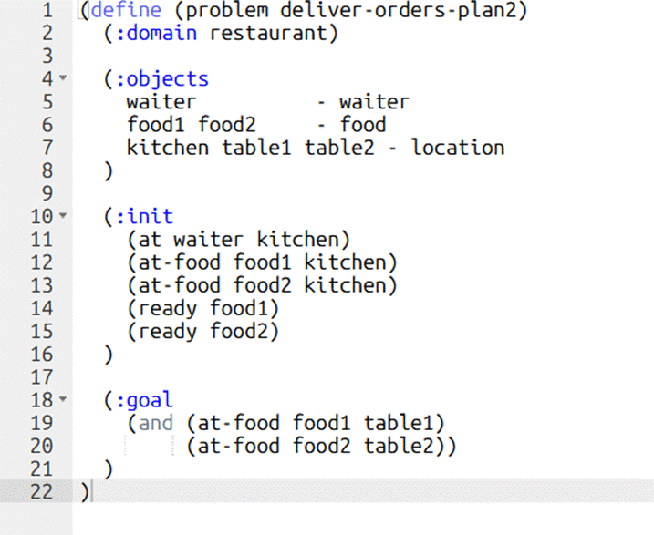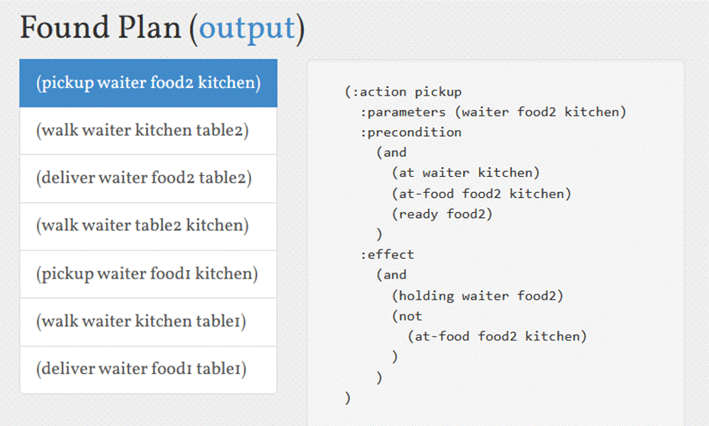

Plan3: Pick up both, deliver food2 first
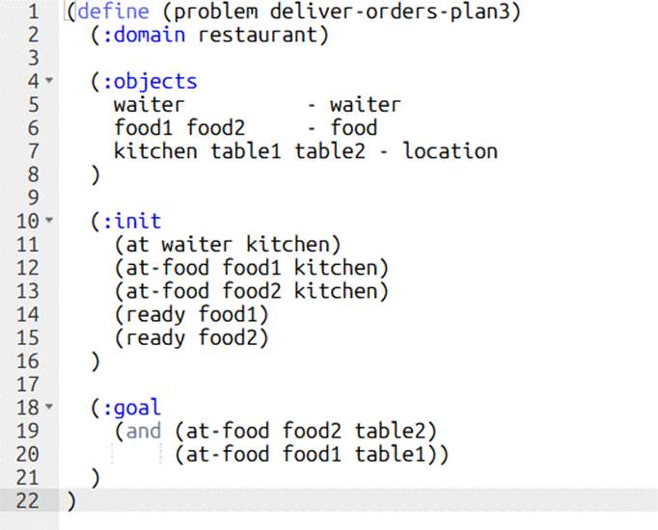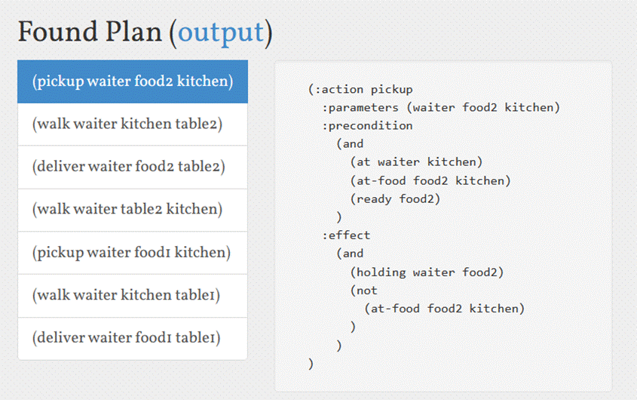

Plan4: Waiter starts at wrong table
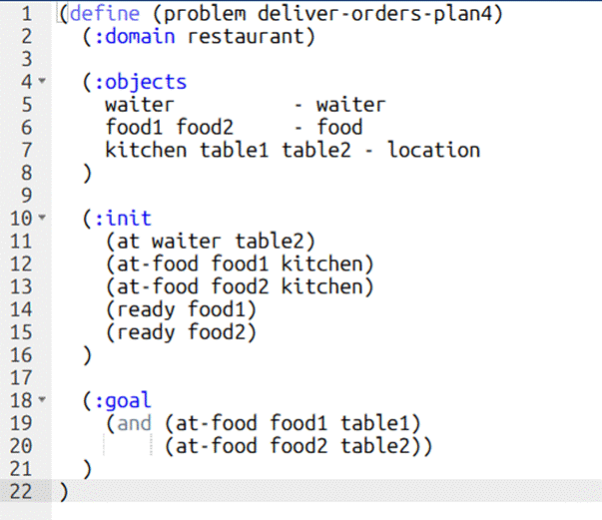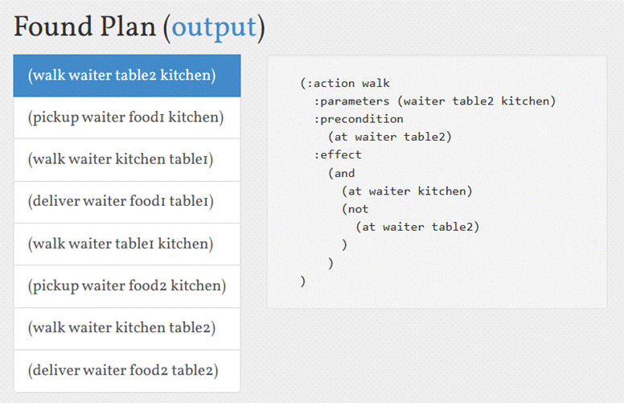

Plan5: Partial Order Plan (POP)
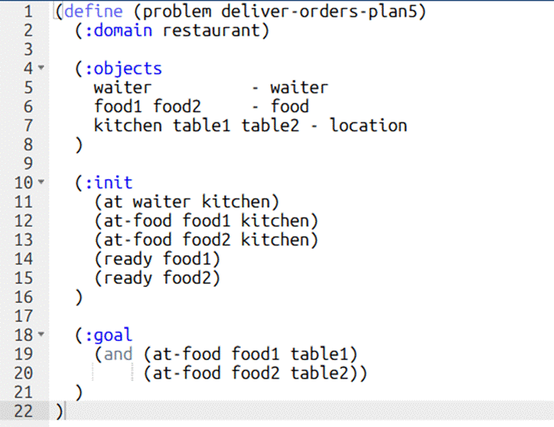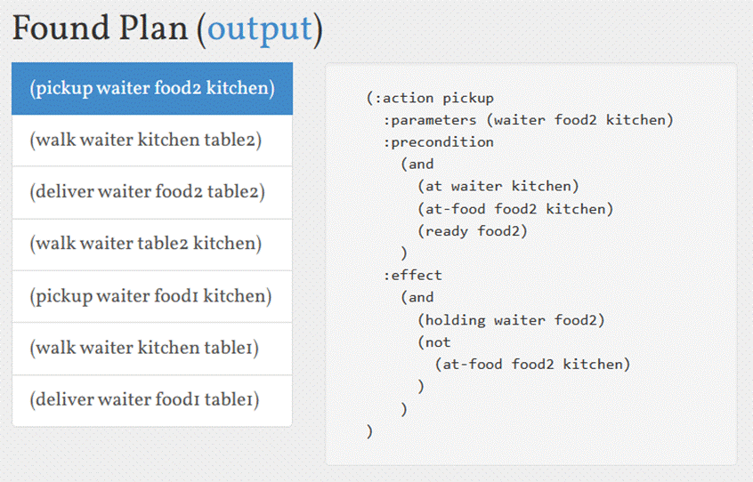

Explanation of PDDL Model:
The domain is named restaurant and uses :strips and :typing requirements. STRIPS ensures classical planning semantics where actions have preconditions and effects, and anything not stated in the initial state is assumed false (closed world assumption). Typing categorizes objects to prevent nonsensical actions like delivering a location or walking a food item.
Three types are defined:
● waiter - the agent performing all actions
● food - the items being delivered (food1, food2)
● location - the places the waiter and food can be at (kitchen, table1, table2)
Four predicates capture the entire state of the world:
● (at ?w ?loc) - tracks where the waiter is
● (at-food ?f ?loc) - tracks where each food item is
● (holding ?w ?f) - tracks whether the waiter is currently carrying a food item
● (ready ?f) - tracks whether a food item is ready to be picked up from the kitchen
Three actions are defined:
● pickup - the waiter picks up a food item at their current location. The food must be ready and at the same location as the waiter. After pickup the waiter is holding the food and it is no longer at that location.
● deliver - the waiter places the food item at their current location. The waiter must be holding the food. After delivery the food is at that location and the waiter is no longer holding it.
● walk - the waiter moves from one location to another independently of what they are carrying.
Initial and Goal States:
The problem file defines the waiter starting at the kitchen with both food items ready and unpacked. The goal requires food1 to be at table1 and food2 to be at table2. The planner finds a valid sequence of pickup, walk, and deliver actions that satisfies this goal. If an incorrect action, such as delivering food to the wrong table, is inserted between the pickup and delivery steps, it would break the plan. Causal links ensure that the required conditions for actions are preserved. For example, once the waiter picks up food, the condition of holding the food must remain true until it is delivered. The causal link prevents any interfering action from violating this condition. Without causal links, the planner would not maintain the correct sequence of dependent actions.

Post Lab Subjective/Objective type Questions:
Question: Answer in brief
- How does ADL (Action Description Language) extend STRIPS?
ADL extends STRIPS by allowing more expressive action representations such as conditional effects, disjunctions, negation, and quantified variables. This makes it possible to model more complex planning problems compared to basic STRIPS.
- Define Partial Order Planning (POP) and Total Order Planning (TOP). How do they differ?
Partial Order Planning (POP) allows actions to be executed in any order as long as constraints are satisfied, enabling flexibility and parallelism. Total Order Planning (TOP) follows a strict linear sequence of actions where each step is fixed. POP is more flexible, while TOP is simpler but rigid.
- Would Partial Order Planning be beneficial in this problem? Why or why not?
Yes, Partial Order Planning is beneficial because the waiter can deliver food items independently, and some actions do not depend on strict ordering. This flexibility allows more efficient planning and reduces unnecessary constraints.
- Describe a situation where causal links would be needed in Partial Order Planning for this problem.
Causal links are needed when ensuring that once the waiter picks up food, no action interferes before delivery. For example, after picking up Food1, an unnecessary walk or drop action should not occur before delivering it to the correct table.
- What are causal links in Partial Order Planning (POP)? Why are they important?
Causal links represent dependencies between actions where one action establishes a condition required by another. They are important because they maintain the correctness of the plan by preventing actions that might break required conditions.

Conclusion:
This experiment successfully demonstrated planning using STRIPS and PDDL by modeling a real-world problem involving a waiter delivering food. The use of predicates, actions, and goal states helped in understanding how planning differs from traditional search. The experiment highlighted the importance of structured representations, causal links, and planning strategies such as Partial Order Planning in generating efficient and logically correct action sequences.

